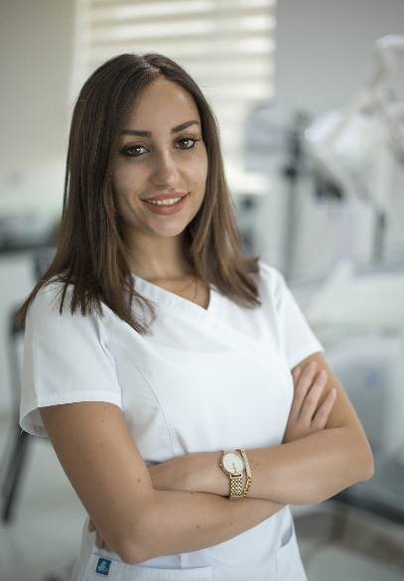 |  | dR.NADIN TAMIMI  DOCTOR OF DENTAL SURGERY  DDS MFDS(RCSI) DipOrth PgDipFacialAesthtics
Profile  Dr.Nadin is a dental surgeon experienced in non-surgical facial Aesthetic procedures including dermal filler and Botulinum toxin injections,mesotherapy,plasma treatments and fractional laser resurfacing in addition to non-surgical facelift with P(LACL) Aptos threads.  Dr.Nadin has a passion for the art of facial Aesthetics and has dedicated her career towards learning and developing new techniques in advanced facial rejuvenation.  Dr.Nadin's precision and attention to details have rewarded her with a first class reputation amongst her patients.  Contact  PHONE:  00962795785798  WEBSITE:  www.Alsalemclinics.com  EMAIL:  Drnadintamimi@hotmail.com  Nadin_tamimi87@hotmail.com |  | EDUCATION  2010 Degree of Doctor of dental surgery (DDS) - Jordan University.  2011 Postgraduate certificate in Oral Implantology, Deutsche Gesellschaft für Zahnärztliche Implantologie e.V. - (Cologne, Germany).  2013 Certificate in orthodontics – Progressive Orthodontics Seminars. (Madrid-Spain).  2013 Diploma in orthodontics – McGann institute (Madrid-Spain).  2015 Member OF the Royal college of surgeons in Ireland.  2017 Master course in Facial Aesthetics, comprehensive applied science and hands on training – (American Aesthetic Association).  2018 Diploma in Facial Aesthetics and orthodontics McGann institute – Lisbon- Portugal  WORK EXPERIENCE  Works in a private Dental practice ( Alsalem Dental clinics ) in Amman-Jordan from 2010 till present.

